**Kubernetes Certification Challenge**

**<https://minikube.sigs.k8s.io/docs/tutorials/multi_node/>**

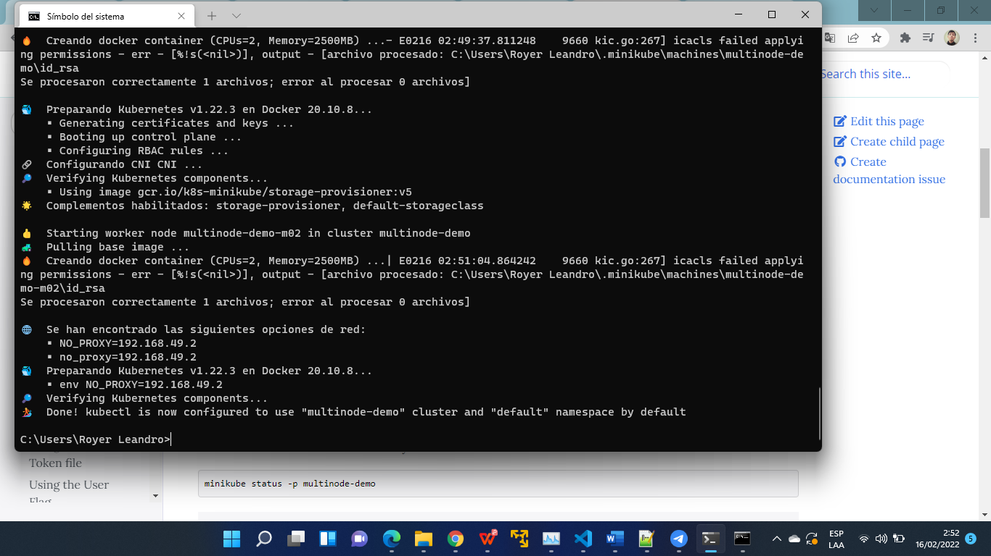

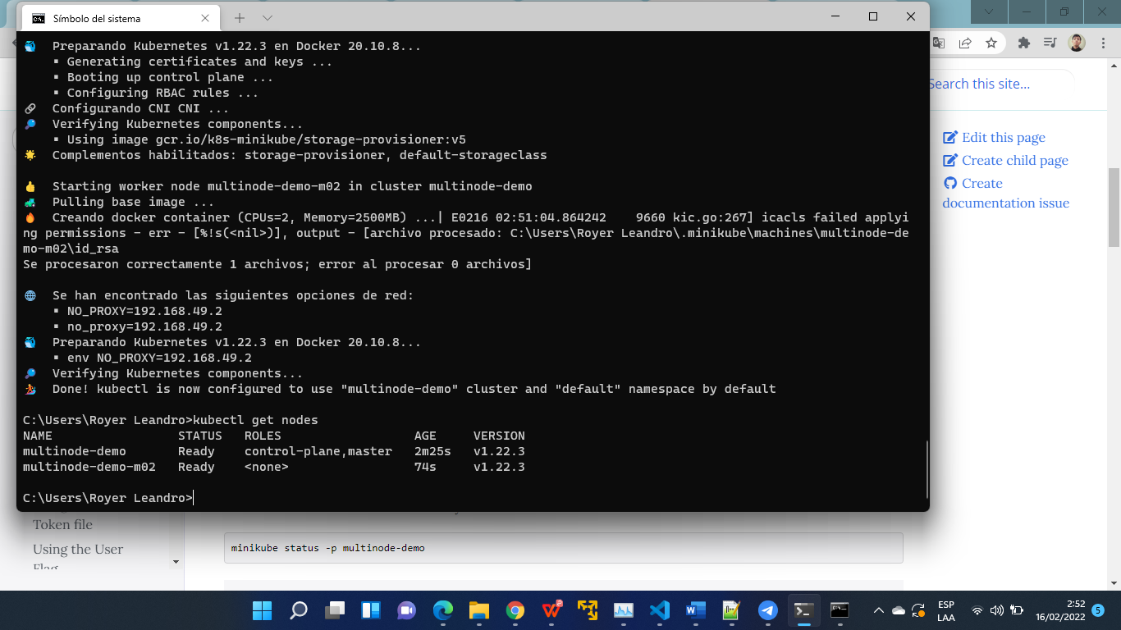

Revisar y ejecutar el siguiente manual

<https://www.containiq.com/post/kubectl-top-pod-node-for-metrics>

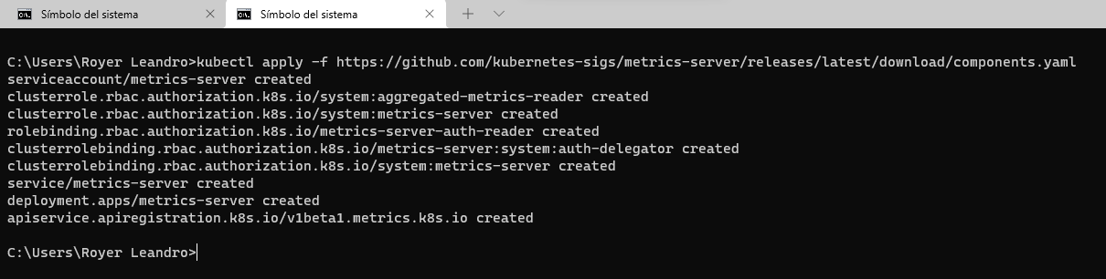

Kubernetes Certification Practice Check 1: Created Specified Deployment

Create a deployment named chk1 in the cal namespace. Use the image nginx:1.15.12-alpine and set the number of replicas to 3. Finally, ensure the revision history limit is set to 50.

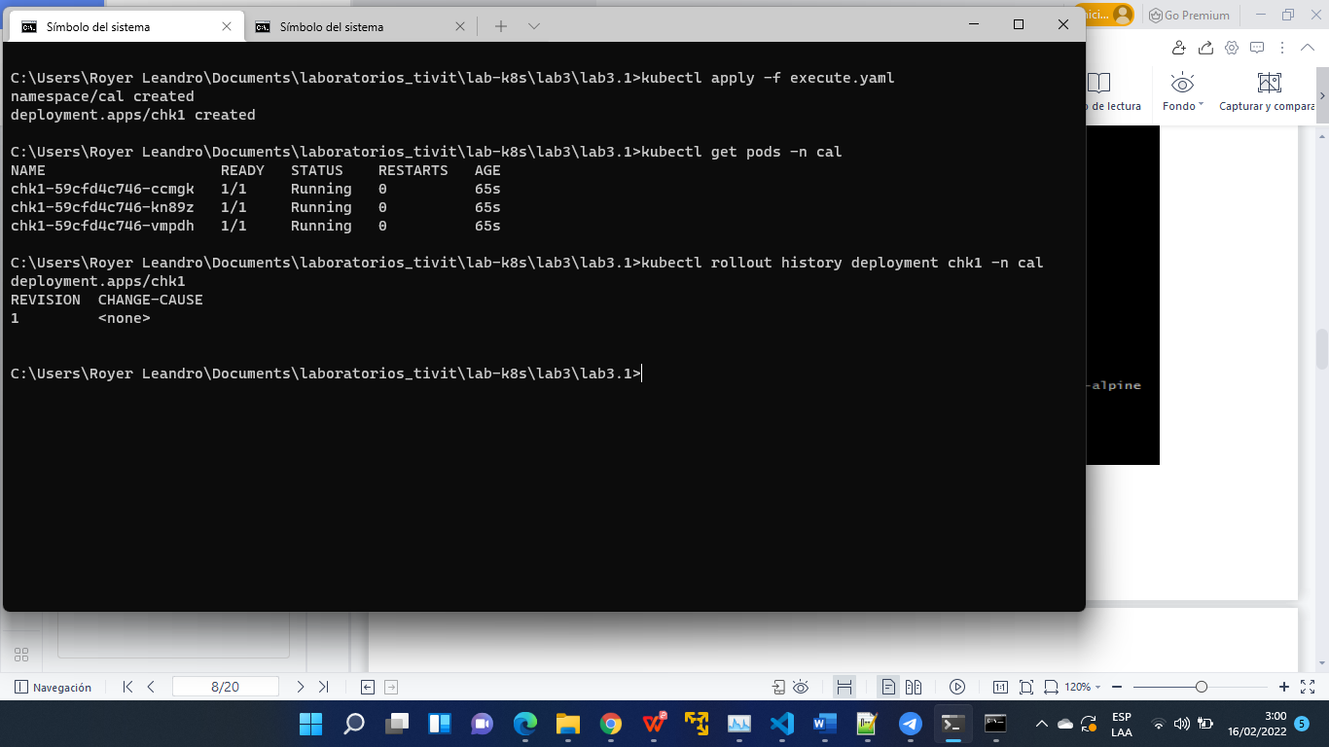

Kubernetes

Kubernetes Certification Practice Check 2: Resolve Configuration Issues

The site deployment in the pwn namespace is supposed to be exposed to clients outside of the Kubernetes cluster by the sitelb service. However, requests sent to the service do not reach the deployment's pods. Resolve the service configuration issue so the requests sent to the service do reach the deployment's pods.

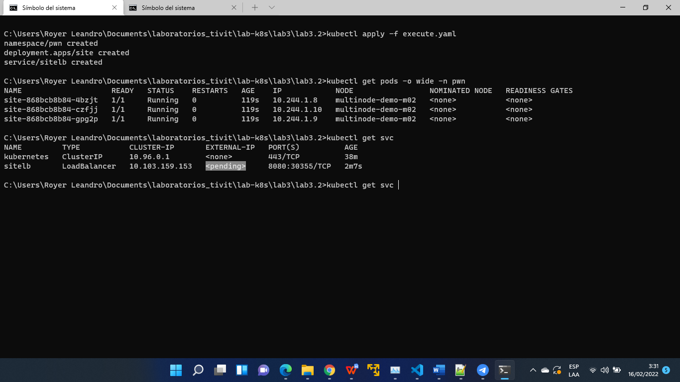

**Nota.- Para poder obtener la EXTERNAL-IP. Revisar el lab2 (Creación de Cluster Aws)**

Kubernetes

Kubernetes Certification Practice Check 3: Highest CPU Pod

Write the name of the pod in zz8 namespace consuming the most CPU to /home/ubuntu/hcp001. The content of the file should be only the name of the Pod and nothing more.

Kubernetes

Kubernetes Certification Practice Check 4: Pod Secret

In the sjq namespace, create a secret named xh8jqk7z that stores a generic secret with the key of tkn and the value of hy8szK2iu. Create a pod named server using the httpd:2.4.39-alpine image and give the pod's container access to the tkn key in the xh8jqk7z secret through an environment variable named SECRET_TKN.

